**ASSIGNMENT SUBMISSION N°5: END MODULE 5**

**COURSE TITLE**

**PGD 002 POST GRADUATE DIPLOMA IN WATER, SANITATION AND HYGIENE (WASH)**

**BY**

**YAHAYA AOUEL**

**ADMISSION NUMBER:**

**30st DECEMBER 2019**

1. Paul, a resident in the outskirts of your town, consults you about building a latrine in the compound of his house. He is an open-minded man who is keen to improve life for his family. He has a wife and three young children, and his elderly mother also lives with them. He doesn’t have a tap in his house and gets water from a nearby well. The area has heavy soil and the rock below is impermeable.
2. **Which types of latrine are possible choices for him?**

**Answer:**

The possible choices are a ventilated improved pit latrine, an Arborloo, a urine-diverting latrine or a biogas latrine; since he doesn’t have a piped supply of water, Mr Paul cannot install a water carriage system; instead, he has to install a dry latrine system.

1. **Ventilated Improved Pit latrine (VIP latrine):** According to Harvey, P.A. (2007), The Ventilated Improved Pit (VIP) latrine is an improved pit latrine designed to minimize odour and flies. A vent pipe is incorporated into the design to remove odorous gases from the pit. This should ideally be situated outside the latrine interior, should extend at least 50 cm above the latrine superstructure and should be painted black to increase solar heating of the air in the vent pipe, causing it to rise. Air should be able to flow freely through the squat hole and vent pipe, therefore no drop hole cover is required.The open end of the pipe is covered with a gauze mesh or fly-proof netting which is designed to prevent flies entering the pit and to trap any flies trying to leave. The superstructure interior should be kept reasonably dark to deter flies, but there should be a gap, usually above the door, to allow air to enter.

This gap should be at least three times the cross-sectional area of the vent pipe (Franceys et al., 1992).

Air flow can be increased by facing the door of the superstructure towards the prevailing wind. Each drop hole should have its own compartment and there should always be one vent pipe per compartment.

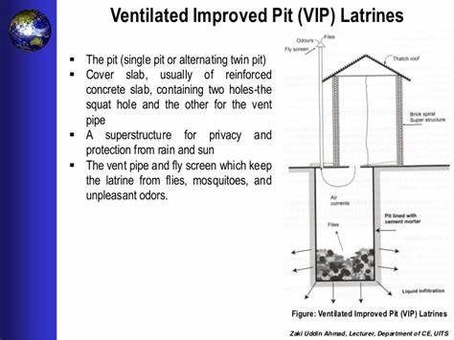

VIP Latrine

Source: Source: Barbara E and Duncan M (2011), Sanitation and Water Supply in Low-income countries.

1. **Arborloo in use:** According toBarbara E and Duncan M (2011), this is shallow pit latrine (typically 0, 80 m in diameter and 1 m deep) which is used for 6-12 months. After each time, the latrine is used soil, ash or leaves are added to the pit (after one use, add one of these; after the next use one of the other two; after third use, the remaining one and so on; this ensures good production of humus production in the pit). When the pit is full to within around 20 cm of the ground surface, the latrine superstructure over a new pit and the full pit covered with soil and a fruit or medicinal tree planted in it. Eventually the household has an orchard of high-value trees which generates both high quality fruit and an income from the sale of excess fruit and or medicinal products “excreta in, money out”. In many rural households the men are away working in nearby towns or mines and the women generally like the Arborloo as they can dig the shallow pits themselves quite easily; moreover there is the advantage that, while nutrients in the excreta are used to fertilize the trees, there is no handling or either faeces or urine (which people would find repugnant).

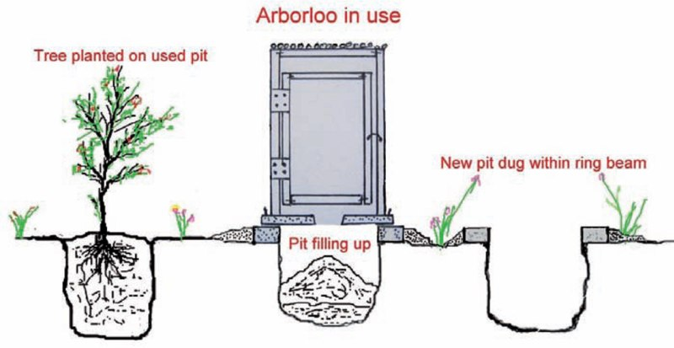

Arborloo latrine

Source: Barbara E and Duncan M (2011), Sanitation and Water Supply in Low-income countries.

1. **Urine-diverting latrine:** Barbara E and Duncan M (2011) defined the urine-diverting latrine as EThekwini latrine (named after the municipality in Kwazulu-Natal, where it was originated), it is a urine-diverting alternating twin-vault ventilated improved vault latrine (or UD-VIV for short). It is wholly above ground and comprises two separately ventilated vaults which receive only faeces and anal cleansing materials; the urine diverted in a specially designed toilet bowl or squat-plate is discharged into a small adjacent soakaway. This is done to keep the vault contents from becoming too wet, so they can hydrate easily. One vault is used for 12 months when the other vault is put into service, after the second vault has been used for 11 months. The first vault is emptied by the householder (using a long handled shovel; the vault content are buried on site), so that the first vault can be put back into service at the beginning of the third year. This sequence of alternating vault usage continues indefinitely. In some locations, usually in rural areas, where appropriate market exists, treated excreta from urine–diverting (EThekwini) latrine can be used or even sold as fertilizer (urine) or soil conditioner (faeces). They stated that the principal advantage or urine–diverting (EThekwini) latrine over VIP latrine is its much greater ease of emptying.

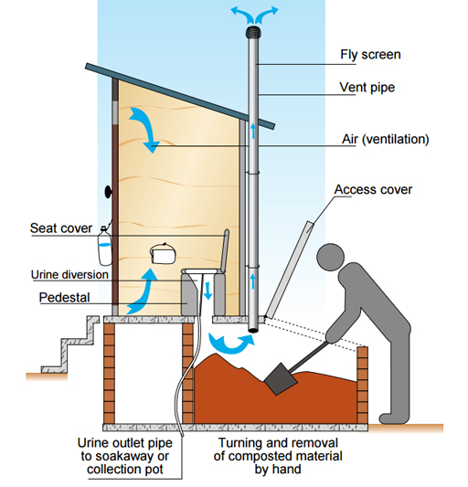

Urine-Diverting-Latrine. Source: PGD002 Post –Graduate Diploma in Water Sanitation and Hygiene Module 5.

1. **Biogas latrine**

According toBarbara E and Duncan M (2011), Biogas latrine is another simple sanitation option for small town and large villages. Households have pour-flush toilets squat-span which discharges into a small anaerobic digester from which the biogas is collected and used for cooking and or other domestic purposes (for example lighting). To increase biogas yields, animal excreta are also often added to the digester. At intervals of 1-2 years, the digester is desludged and the sludge so removed is either buried on site or used to fertilize a small vegetable plot. There are many such biogas toilets, especially in the Far-East. In small towns in Vietnam for example most holds have 3 to 4 pigs and both the pigs and human excreta are discharged into a 1m3 anaerobic digester and the resulting biogas is used for cooking.



Basic component of a Biogas latrine. Source: PGD002 Post –Graduate Diploma in Water Sanitation and Hygiene Module 5.

1. **Which types of latrine would you recommend, and why?**

**Answer:** Before recommending him the type of latrines let me give and analyse first the advantages and constraints of the each of the possible choice without forgetting the constraint related to his house.

**Advantages of VIP latrines**: Odour and flies are reduced and a good quality long-term solution.

**Constraints of VIP latrines**: VIP latrines are difficult and expensive to construct properly; design and operation are not often fully understood; construction may time; dark interior may deter young children from using the latrine; design does not deter mosquitoes and there is an increased odour outside.

**Advantages of Arborloo in use:** ensures good production of humus production in the pit; eventually the household has an orchard of high-value trees which generates both high quality fruit and an income from the sale of excess fruit and or medicinal products “excreta in, money out”; while nutrients in the excreta are used to fertilize the trees, there is no handling or either faeces or urine (which people would find repugnant); was found to provide a simpler solution with resource reuse.

**Constraints of Arborloo in use:** Too much pits are to be dug one after the other; require frequent movement of superstructure from a full pit to the new one; the design is not appropriate in regions where either excavation is not possible or where high groundwater is present (Kinstedt, 2012, p. 1).

**Advantage of urine-diverting latrine:** The principal advantage or urine–diverting (EThekwini) latrine over VIP latrine is its much greater ease of emptying.

**Advantage of Biogas latrine:** biogas is collected and used for cooking and or other domestic purposes (for example lighting); sludge so removed is either buried on site or used to fertilize a small vegetable plot. I will recommend him the most desirable latrines.

After careful analysis, it is found that the Ventilated Improved Pit latrine would be suitable, but if he has space and farms near him (since he is at the outskirts of town) a composting system is recommended, such as the Arborloo or urine-diverting latrine. This would produce useful organic compost and so protect the environment. In the urine-diverting latrine, a fertilizer from urine is also produced. Mr. Paul could sell these products to the farmers. The biogas latrine is not recommended because it is suitable only where there are a large number of users.

1. **What other advice would you give him about the location, design and construction of the latrine?**

**Answer:**

* The pit must respect the recommended safe distance from the groundwater sources (at least 30 m) away from the well;
* The pit must be at a lower level according to the slope of the land;
* It must be of reasonable dimensions according to the number of his family and visitors;
* He should also consider the wind direction and place the latrine downwind and at a convenient distance from the house;
* For the safety of the children, he should choose a SanPlat for the slab;
* He should seek advice about possible materials to be used for the superstructure;
* The materials should be available locally, so that the system is sustainable;
* He should install a handwashing facility next to the latrine;
* He should be responsible for the supervision, maintenance and cleanliness of the latrine.

**2. Nancy is a laboratory technician. She is analysing a sample of wastewater collected from a pipe that discharges effluent into a river.**

**(a) Name two tests Worknesh could perform to assess the physical characteristics of the effluent.**

**Answer:**

In the definition of physical characteristics given by WHO (1989), The physical characteristics of the effluent include: Solids, temperature, turbidity, colour and smell (odour). To assess the physical characteristics, the Worknesh could perform for example:

* A suspended solids test;
* She could also measure the temperature of the sample and assess the odour. (Note that if she was measuring temperature she would have to do this at the point of origin because the temperature could change within a short time.)

**(b) As part of the analysis she also does a BOD test on the sample and gets an unusually high result. What does the high BOD tell her about the wastewater? What effect could it have on the river?**

**Answer:**

According to WHO (1989), BOD5 is the oxygen equivalent of organic matter. It is determined by measuring the dissolved oxygen used by microorganisms during the biochemical oxidation of organic matter in 5 days at 20oC

A high BOD test result would tell Worknesh that there was a lot of organic matter in the sample. If this was discharged into the river it would remove oxygen from the water, which would harm fish and other organisms living in the river.

**3. What is the purpose of the report of a rapid assessment and who should receive copies of the report? Explain the contents of Rapid Assessment Report**

Answer:

Skillen, J. Wypych, P. & Draisma, K. (1999) explainReports as any document that communicates information which has been compiled as a result of research and analysis of data and of issues. Reports can cover a wide range of topics, but usually focus on transmitting information with a clear purpose, to a specific audience. The purpose of the report is to summarize the results from the assessment and indicates how well it aims have been achieved.

Good reports are documents that are accurate, objective and complete. They should also be well-written, clearly structured and expressed in a way that holds the reader's attention and meets their expectations. The true value of the research may be assessed through a report since the written report may be the "only tangible product of hundreds of hours of work. Rightly or wrongly, the quality and worth of that work are judged by the quality of the written report - its clarity, organization and content" (Blake & Bly, 1993: 119). Often reports are structured in a way that reflects the information finding process and the writing up of the findings: that is, summary of the contents, introduction or background, methods, results, discussion, conclusion and/or recommendations. The inclusion of recommendations is one reason why reports are a common form of writing in industry, as the informed recommendations are useful for decision making. After permission from the funders has been obtained, it should be sent to all those who had an interest in its findings.

Apart from the funders, recipients could include:

* The kebele administration;
* Community representatives;
* The local Health Extension Workers team;
* Any non-governmental organisations (NGOs) or funding organisations who might be willing to finance or support a follow-on programme;
* Any local WASH programmes.

**4. Explain five ways in which urbanisation creates challenges for effective sanitation and solid waste management.**

**Answer:**

Ugwuanyi, R.O. and Isife, C.T. (2012), carried out a study on “urbanization and solid waste management challenges in Nigeria” they reported in their study that urbanisation creates challenges for effective sanitation and solid management by different ways such as: Bad planning and indiscriminate erection of walls, traffic congestion, air pollution, housing and sewer system, water pollution.

* The concentration of the population in urban has a consequence of bad planning and indiscriminate erection of walls and housing structures, block water flow channels to form big floods; increase in domestic waste and bad refuse disposal schemes marked by indiscriminate dumping of solid waste and thrash in drainages and stream channels results in clogging of flow path of rainwater and pollution of surface water systems;
* A first-time visitor to a super city, particularly in a less developed country, is often overwhelmed by the immense crush of and vehicles of all sorts that clog the streets. The noise, congestion, and confusion of traffic make it seem suicidal to venture onto the street;
* The dense traffic (commonly old, poorly maintained vehicles), smoky factories, and use of wood or coal fires for cooking and heating often create a thick pall of air pollution in the world’s super cities. Lenient pollution laws, corrupt officials, inadequate testing equipment, ignorance about the sources and effects of pollution, and lack of funds to correct dangerous situations usually exacerbate the problem (Taylor, 2003);
* Few cities in Nigeria can afford to build modern waste treatment system for their rapidly growing populations. The World Bank estimates that only 35 percent of urban residents in developing countries have satisfactory sanitation services. Absence of sewage proper disposal system cause pollution of surface and ground water systems rendering them unfit for human consumption and contributing to fresh water and degeneration of sanitary conditions in urban areas.(Durotoye, 2003);
* The United Nations estimates that at least one billion people less than 20 percent of the world population live in crowded, unsanitary slums of the central cities and in the vast shantytowns and squatter settlement that ring the outskirts of most third world cities. Around 100 million people have no home at all. Rapid urbanization of small towns results from fast population increase, force human occupation of flood prone areas. Massive destruction of natural ecosystem in the process of urbanization alters natural flow channels to form big floods;
* Many people living very close together which puts pressure on all urban services;
* The rate of increase in population is very fast and the development of infrastructure for water supply and sanitation services cannot maintain the same pace of change;
* People arriving in cities often live in informal settlements which are developed without planning or control and lack essential facilities for the people who live there;

**5. How do good sanitation and waste management practices bring a positive effect to urban inhabitants? Give examples for effects on:**

**a) Effects on health**:

* Good sanitation and waste management help to keep people separate from potential sources of pathogens;
* They reduce the risk of contaminating water supplies with pathogens and discourage the transmission of disease.;
* Wastes left lying around end up in our dams, rivers, springs and contaminate our water and gives us disease when we use this water;
* Domestic wastes left lying on the ground provide a breeding ground for germs which can infect people and cause disease;
* According to Muruka et al. (2012), good sanitation improves the quality of life by reducing communicable diseases. Health improvements come from the proper use of sanitation facilities but the greatest benefits occur when there are improvements in sanitation and water supply combined with education on hygienic practices (Anteneh et al., 2010);
* The benefits of good sanitation and waste management can include convenience, dignity, status, but the most important benefit from the point of view of a WASH program is health; it blocks the faecal-oral route of disease transmission;
* Good sanitation and waste management are essential to the protection of community health by limiting the transmission of infectious diseases;
* In one of its study, The WHO (n.d.) goes on to state that: ....*inadequate sanitation is a major cause of disease world-wide and improving sanitation is known to have a significant beneficial impact on health both in households and across communities.*

1. **Effects on education:**

* Healthy children have fewer days off school through illness;
* When they are at school, healthy children learn better than sick children;
* Providing good sanitation facilities encourages children to attend school, particularly girls during their menstrual periods;
* The children are more able to integrate hygiene promotion into their daily lives and can be effective messengers and agents for change in their families and the wider community;
* The proper behaviours that children learn at school are skills that they are likely to maintain as adults and pass on to their own children.

1. **Effects on economic conditions:**

* The health benefits promoted by good sanitation and waste make for a more productive community;
* Less money is spent on healthcare and people lose fewer days off work through caring for the sick (we lose money when we are ill and cannot work)

1. **Effects on the environment:**

* Good sanitation and waste management means that there will be less faeces and waste deposited in public places and less pollution of the water and soil;
* Most cultures believe that wastes are unsightly and therefore good sanitation also aims to remove these from sight;
* Good sanitation and waste management are essential to the assistance in the maintenance of a sanitary home environment;
* Improved sanitation and waste management reduce environmental burdens, increases sustainability of environmental resources and allows for a healthier, more secure future for the population.

References

Barbara E and Duncan M (2011), Sanitation and Water Supply in Low-income countries.

Harvey, P.A. (2007), Excreta Disposal in Emergencies, A Field Manual, An Inter-Agency Publication.

Skillen, J. Wypych, P. & Draisma, K. (1999). Report Writing Guidelines for ENGG154 Engineering Design and Innovation, University of Wollongong.

Ugwuanyi and Isife, (2012), Urbanization and Solid Waste Management Challenges in Nigeria, Urbanization and Solid Waste Management Challenges in Nigeria.

Charles Muruka et al.(2012), The Relationship between Bacteriological Quality of Dug-Wells & Pit Latrine Siting in an Unplanned Peri-Urban Settlement: A Case Study of Langas – Eldoret Municipality, Western Kenya.